# OOJ Lab Week 1:

## Question:

Implement a Java code to return the roots of a Quadratic equation

## Code:

| import java.util.*;  import java.lang.Math;  class Quadratic{  public static void main(String args[]){  Scanner sc = **new** Scanner(System.in);  System.out.println("Enter the values of a, b, c for the quadratic equation:");  double a = sc.nextDouble();  double b = sc.nextDouble();  double c = sc.nextDouble();  double discriminent = b*b-4*a*c;  if(discriminent > 0){  double result1 = (-b+Math.sqrt(discriminent))/(2*a);  double result2 = (-b-Math.sqrt(discriminent))/(2*a);  System.out.println("The roots are real and distinct: " + result1 + " and " + result2);  }  else if(discriminent == 0){  double result = (-b+discriminent)/(2*a);  System.out.println("The roots are real and same: " + result);  }  else{  double realPart = -b/(2*a);  double imaginaryPart = Math.sqrt(Math.abs(discriminent))/(2*a);  System.out.println("The roots are imaginary: " + realPart + "+i" + imaginaryPart + " " + realPart + "-i" + imaginaryPart);  }  }  } |
| --- |

## Output:

### Output 1 (real and not distinct):

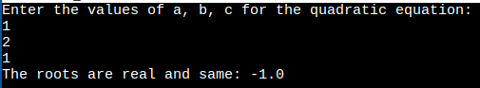

### Output 2 (real and distinct):

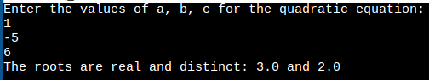

### Output 3 (imaginary):

